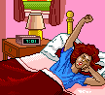

I get up early .

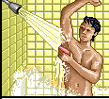

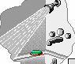

a shower

I take a shower in the bathroom

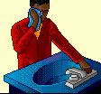

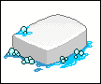

a soap

I wash my face with a soap.

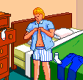

I wear my clothes in my room.
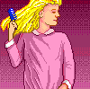

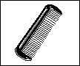
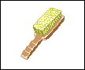

a comb a hair brush
I comb my hair with a comb.

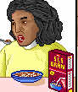

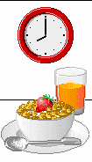

I have breakfast in the dining – room / in the kitchen / in the garden
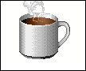
I drink my coffee

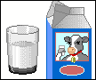
I drink my milk

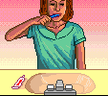

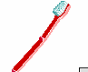

a teeth brush

I brush my teeth.

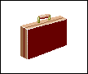
a bag

I take my bag and go to school.
Singular | Plural
foot | feet
tooth | teeth

On Monday, Tuesday, Wednesday , Thursday,Friday and Saturday , I get up early because I go to school .

Lesson 30 Unit 11
On Sunday I get up late
because I don’t go to school ,it’s a holliday

